
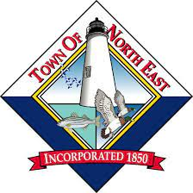
OPEN HOUSE
APRIL 14, 2026 5:00 – 7:00 PM
5:00 PM – BRIEF INTRODUCTION
6:00 PM – BRIEF INTRODUCTION

NORTH EAST LIBRARY
485 MAULDIN AVENUE, NORTH EAST, MARYLAND

*THE DRAFT 2040 COMPRENHENSIVE PLAN CAN BE VIEWED ON THE TOWNS WEBSITE:
WWW.NORTHEASTMD.ORG

NORTH EAST PLANNING COMMISSION &
COMPRENENSIVE PLAN STEERING COMMITTEE
INVITE YOU TO STOP IN TO REVIEW THE DRAFT 2040 COMPREHENSIVE PLAN DURING OUR

NORTH EAST COMPREHENSIVE PLAN
2040 | TOWN OF NORTH EAST

